# CS 255 System Design Document Template

This template lays out all the different sections that you need to complete for Project Two. Each section has guidance to prompt your thinking. You will need to continually reference the interview transcript as you work to make sure that you are addressing your client’s needs. There is no required length for the final document. Instead the goal is to complete each section based on what your client’s needs are. Remove this note when you are finished, and replace all bracketed text with the relevant information.

## UML Diagrams

### UML Use Case Diagram

*[In Module Six, you were asked to complete a use case diagram based on your system design. If you would like to make any adjustments to your diagram, please do so. Please insert your use case diagram here. Check to make sure that you included appropriate components and symbols and that your design meets the client’s needs.]*

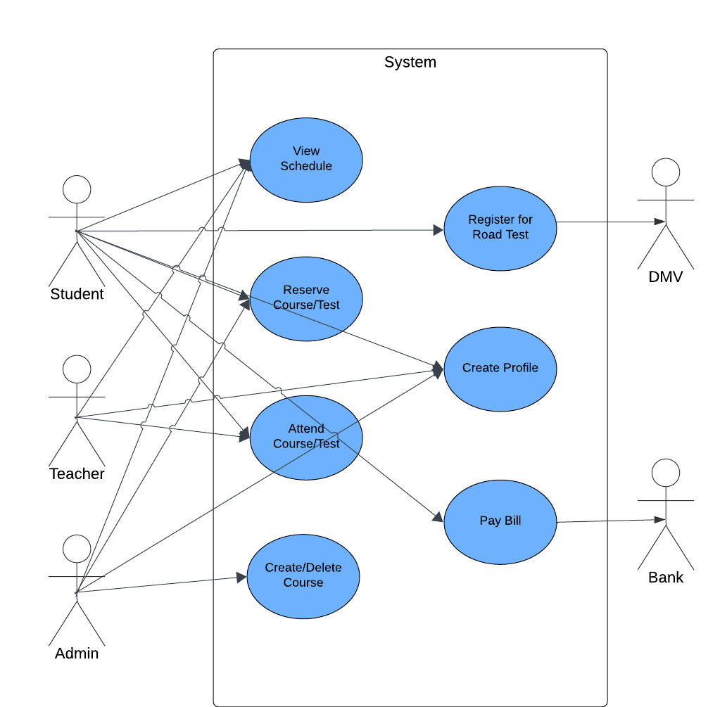

### UML Activity Diagrams

*[You were asked to choose* ***two*** *use cases and create* ***two*** *activity diagrams, one for each use case. Please insert* ***both*** *of your activity diagrams here. Check to make sure that you included appropriate components and symbols and that your design meets the client’s needs.]*

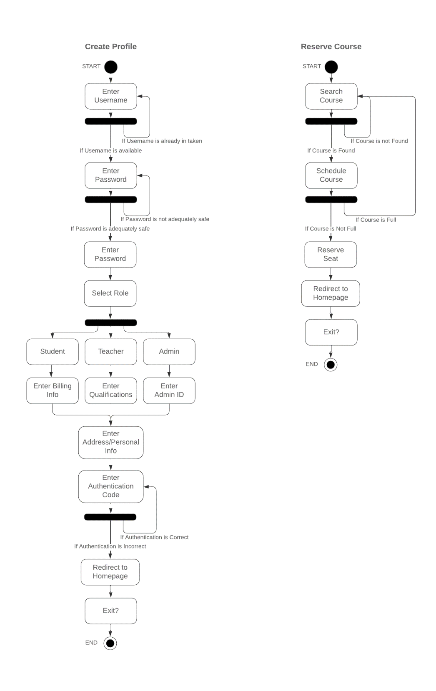

### UML Sequence Diagram

*[You were asked to create a sequence diagram based on* ***one*** *of the use cases you chose. Please insert your sequence diagram here. Check to make sure that you included appropriate components and symbols and that your design meets the client’s needs.]*

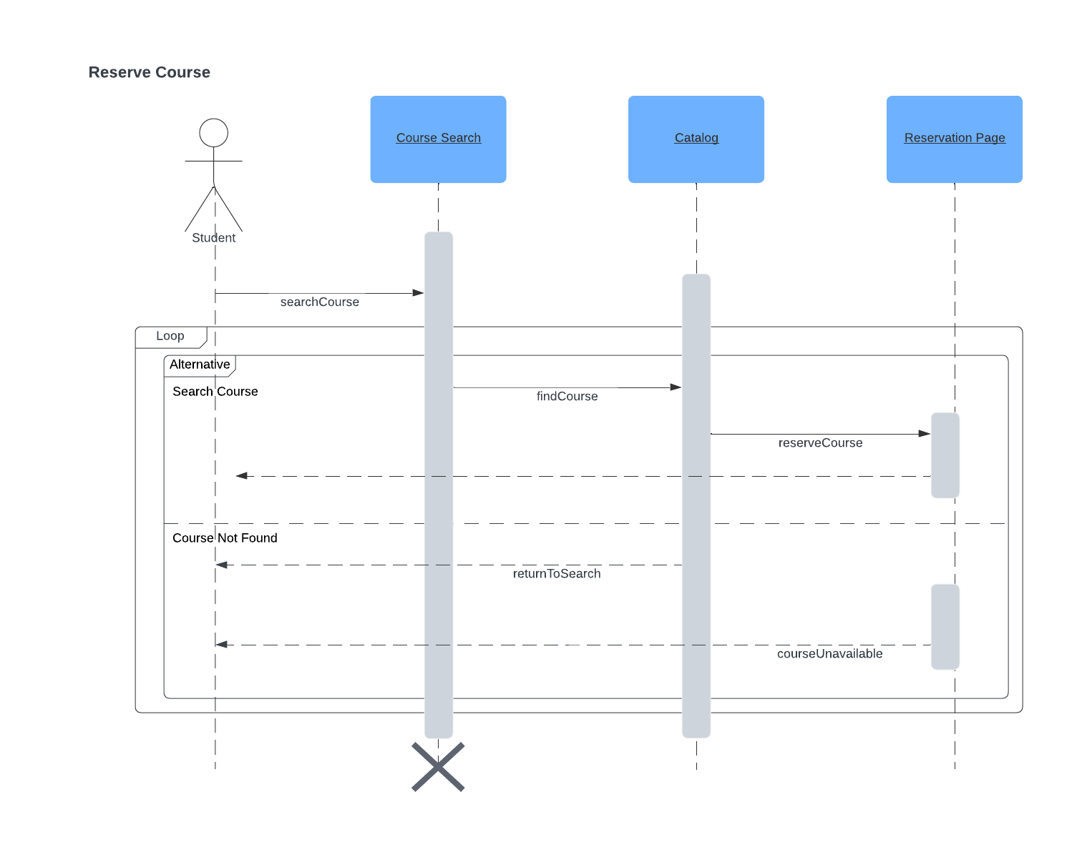

### UML Class Diagram

*[You were asked to create a class diagram based on the different classes and attributes needed for your system design. You are* ***not*** *required to include methods, but you may if you wish. Please insert your class diagram here. Check to make sure that you included appropriate components and symbols and that your design meets the client’s requirements.]*

## Technical Requirements

*[Based on the diagrams you have created, describe the technical requirements of your system. These requirements should address the required hardware, software, tools, and infrastructure necessary for your system design.]*

**Hardware**

The system will be built with low computational demands so that any user can access and utilize the site with personal computer equipment of sufficient capacity to access basic programs and internet systems. The system will also be built so that users can see the site and interact with it via GUI. Further, the system will be designed so that the user can interact using peripheral equipment such as mouse and keyboard to complete basic actions like search, log in, and program termination.

**Software**

The system will be made for use on either WindowsOS or MacOS so that the majority of users can access the system without difficulty or compatibility issues. The software will be efficient to ensure high speed course access and accuracy is maintained. The system will be designed without bottleneck and separated sub-systems to sequester processes such as “course reservation” from databases such as “course catalog.” The system will run on the cloud and be accessible anywhere which limits the need to develop security or backup systems, but we will ensure an account verification system is built and functional for user account creation and sign-on.

**Tools**

Tools will be comprehensive, meet the needs of all users, and include:

* Course creation only accessible by administrators
* Course scheduling for students and teachers
* Content delivery system for video courses
* Calendar system for tracking upcoming work
* Account/Profile creation for all users
* User database tracking all users
* Course database tracking all courses
* Test registration for final test with DMV
* Billing system to help students pay their fees
* Administrator access to data via bulk export and API
* Activity Tracking of all users
* API link to DMV for updates on rules, regulations, and policies
* Homepage with test progress, driver notes, user info, special needs, and photos

These tools will be focused on the basic needs of the site and not employ overly complex or advanced methods. The owners of DriverPass have expressed concern that they may not be able to employ enough staff with the required expertise to maintain their systems and will need to do some of the work themselves. With effective but simple tools, they will be able to keep the site running, maintain all functionality, and keep the user experience positive.

**Infrastructure**

The system will exist on the cloud to ensure that hosting, security, backup, and reliability are outsourced to larger and more capable service providers. Within the system build itself, basic sub-systems will be built for each of the tools and functions of the system in standardized form and in keeping with the goal of making the system easy to maintain for the limited staff of DriverPass. It will link all related modules as necessary and offer viewable pages that can be seen via GUI and navigated via standard peripherals such as keyboard and mouse. To ensure this need is met, we will rely heavily on the native services of the cloud provider. This will dictate how these sub-systems are built and made to interact with one another. Further, it is the most cost-effective and simple-to-use approach.